Certificate of Analysis

General properties:
Name： NHS-PEG3400-PDLLA5000
Molecular Weight： PEG MW:3400, PDLLA MW:5000
Cat.#： RQD10336
Lot.#： RN0162066
Manufacture Date： 2016.06.20
Date of Analysis： 2016.06.20
Recommended Retest date： 2017.06.20
Stability： 12 months
Storage： -20°C in the dark

Structure

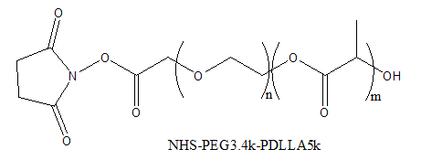

Items | Specification | Results
Appearance | White/ Off-white solid | Off-white solid
¹H NMR | Identical to the structure | Identical to the structure
Foreign Material | None | None
Substitution | ＞90% | 92%
PDI |  | ＜1.3
Report Date: 2016.06.20

This product is for research use only, Not for human or animal use

